What happens inside the lungs during
an asthma attack?

The air that you breathe goes from your mouth and nose to your lungs, which are located under your ribs. The lungs are made up of airways that get smaller and smaller, like the branches of a tree.

When your asthma is well controlled, your airways are wide open and you can breathe easily (see the "Healthy airway" diagram below).

During an asthma attack, three things happen:

1. The airways get squeezed a little. Tiny muscles around the airways squeeze like rubber bands that are just a little tight. This is called "bronchospasm."
2. The sides of the airways swell up. This makes the airways sensitive to things that start asthma attacks. This is called "inflammation."
3. The insides of the airways make too much mucus.

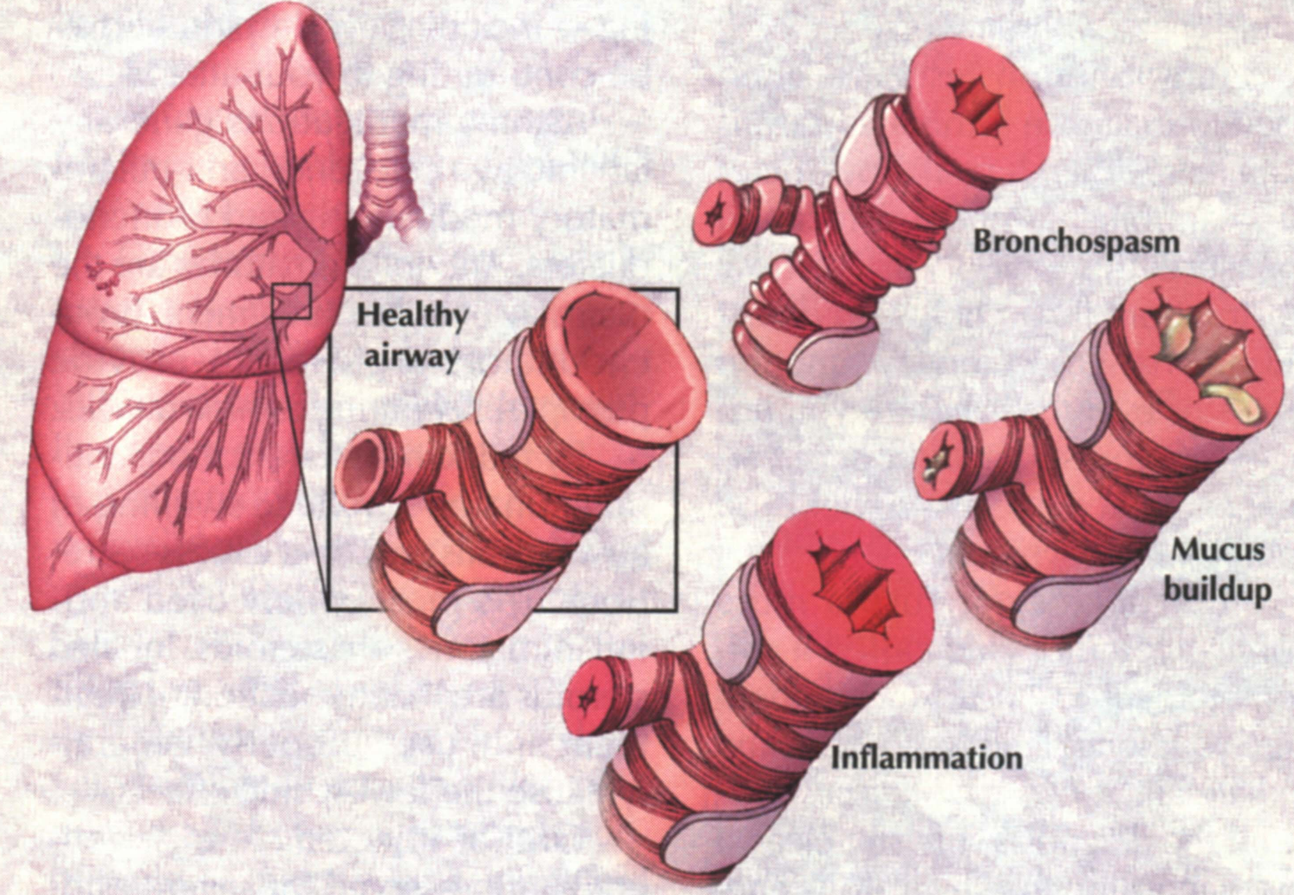

© Copyright Mayo Foundation for Medical Education and Research. All rights reserved. Used with permission from the Mayo Clinic Health Letter newsletter.

Medicine will open up the airways. One kind is taken every day to keep swelling down. Another kind relaxes the muscles during an asthma attack so the muscles will not squeeze the airways.

